AutocheX Quick Start Guide

The Customer Experience Program (AutocheX)

Viewing your Mitchell AutocheX reports and surveys
There are a number of reports that all AutocheX users will have access to. You are able to view your data for each carrier program you participate in that utilizes AutocheX.
Go to your Desktop and double-click the RepairCenter™ icon.

In order to access RepairCenter and your CEM reports, you will need to log into RepairCenter using your assigned username and password. Click Log In. Note: Your log-in information is confidential and specific to your shop. If you have forgotten your password, please select the Forgot Password link.
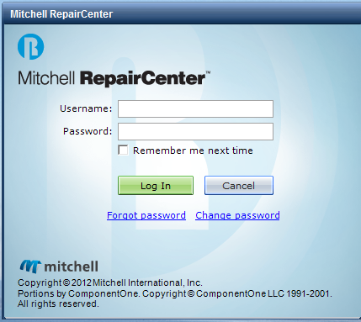

AUTOCHEX/REPAIRCENTER CEM ORIENTATION
From the menu, select “Surveys”.
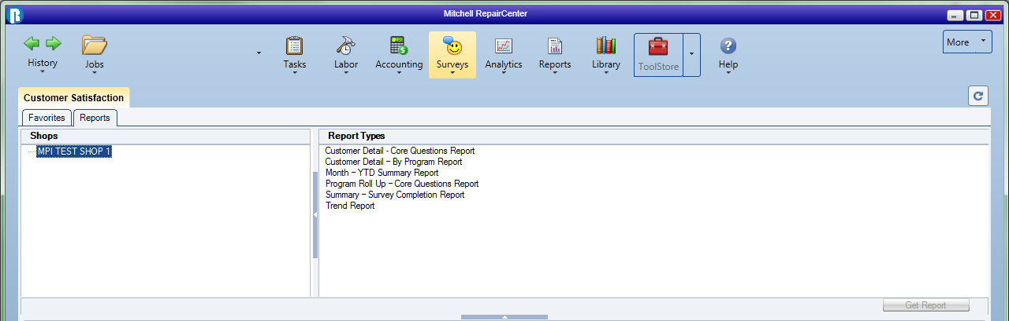

If the “Survey” icon does not appear in the Top Menu please contact Mitchell Tech Support at 1-800-448-4401, select Option 2 for Technical Support”. Or you can create a support ticket via MiPortal Customer Support at https://www.mitchell.com/support

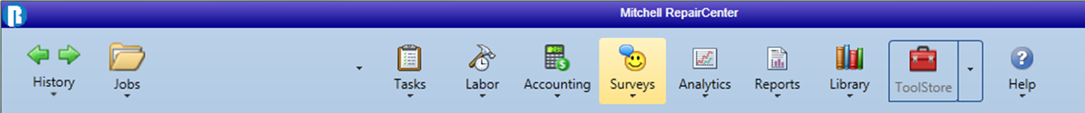

Select the reports tab. There are three main areas within the Customer Satisfaction section as shown below:

Shops, Report Types, and Report Information – this is where the report renders (located in the lower part of the screenshot)

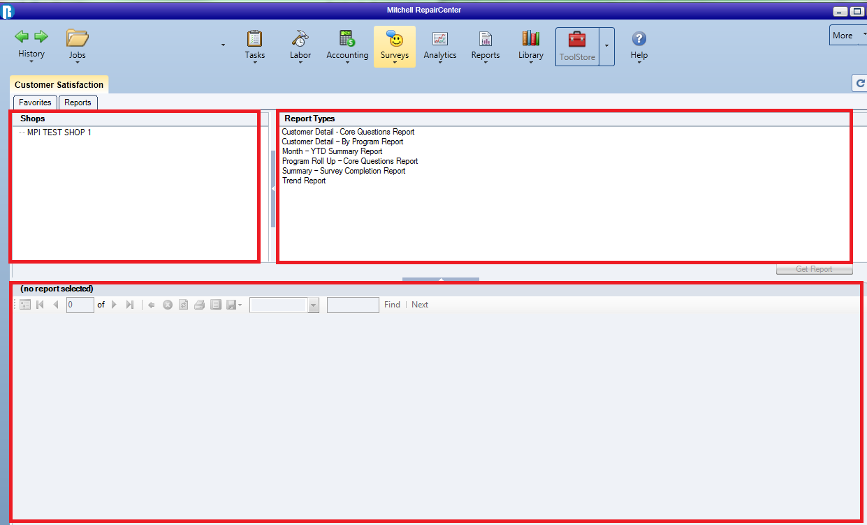

In the Report Types section, choose the desired report. Once selected, click “Get Report”, the report will generate in the lower part of the screen.

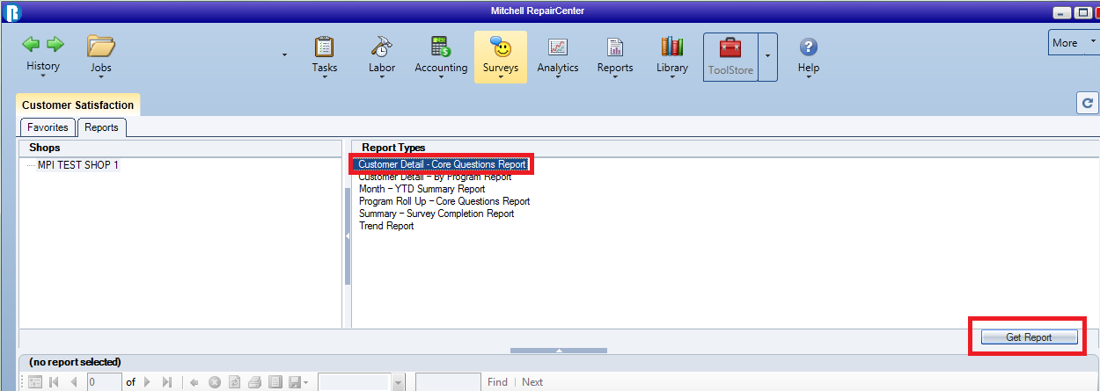

If you would like to adjust the parameters on your report, you can select different options. In this example, if you would like to view the November date range, you would make your selection in the “Start Month” and “End Month”, and then click the “View Report” button.

The report will render in the lower section, depending on what was selected. Click on the customer name link within the report to view any comments the customer may have provided with their survey response.

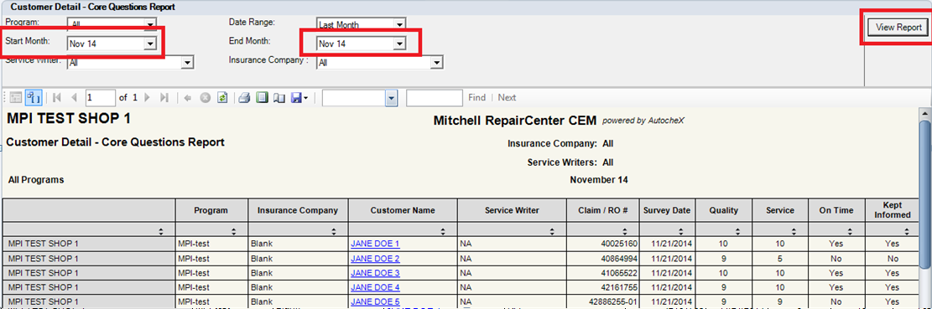

Once run, the reports can also be exported and printed in a variety of formats (Excel, PDF, CSV, etc.) by selecting the export icon, which will display a drop down and allow you to select your preferred format. This is located in the toolbar directly above the report.

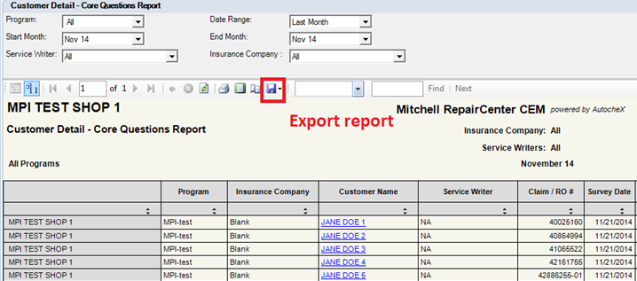

Mitchell AutocheX reports types

Customer Detail Core Questions
This report shows the survey responses and alerts to the core questions (quality, customer service, on-time delivery, kept informed, return vehicle and refer shop) for all customers across all carrier programs in which you participate. Alerts are displayed on all responses with an A and indicate where the person responded to the Refer Shop question with a score between 1 and 6. If you opted to receive emailed alerts, you would have also received a Customer Alert e-mail that included a copy of the survey. Customer Alerts are usually sent the next business day after the interview is completed. 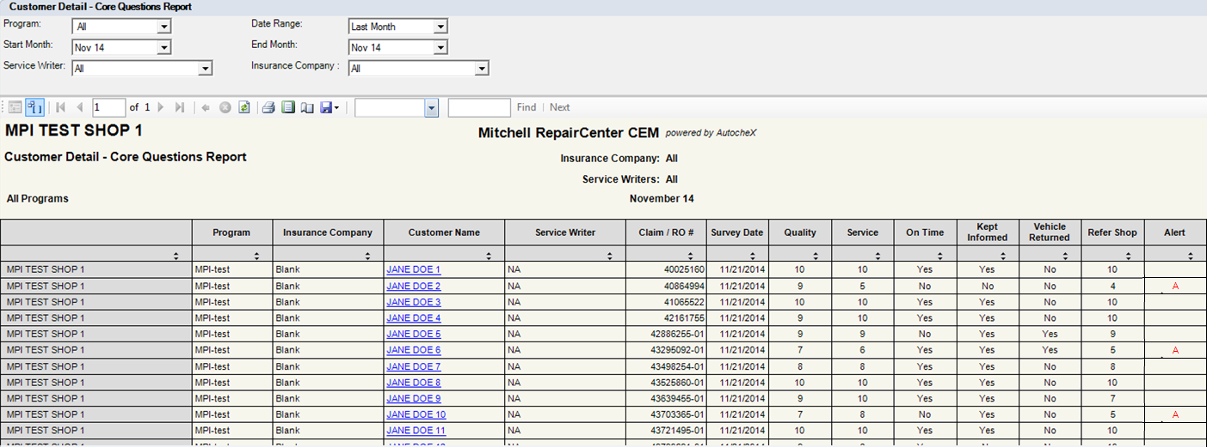

Customer Detail by Program
This report will display all the scores and alerts by customer for each question by specific carrier selected.

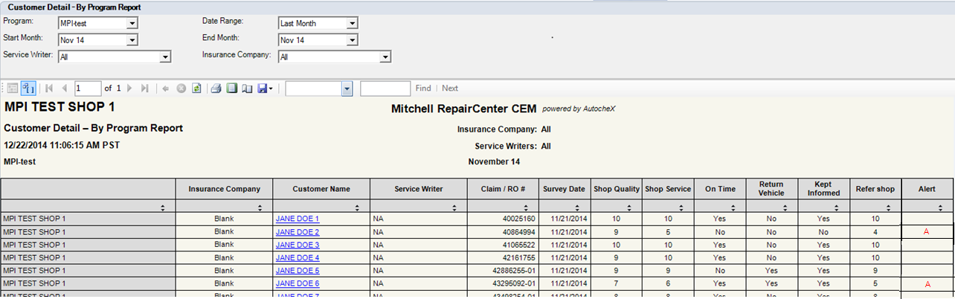

The Month-YTD Summary Report
This Month-YTD Summary Report shows your shop’s monthly and YTD performance on the core questions in the specific month selected for the program(s) selected.

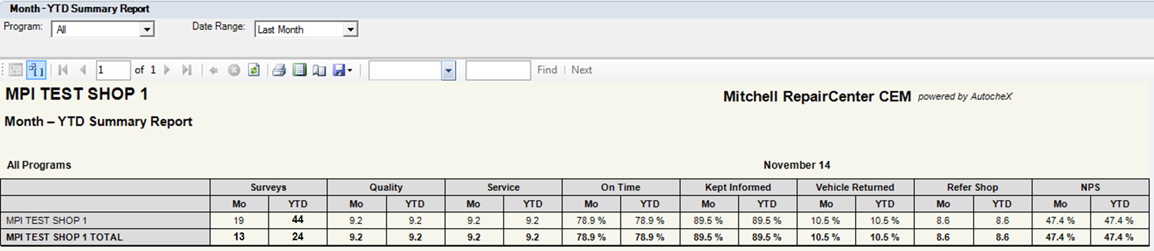

Program Roll Up – Core Questions Report
This report shows each of the AutocheX programs your shop participates in, and your shop’s performance on the core questions for those programs during the time period selected. The core questions are Quality, Service, On Time, Kept Informed, Vehicle Returned and Refer Shop. The result for NPS (Net Promoter Score) is also displayed.

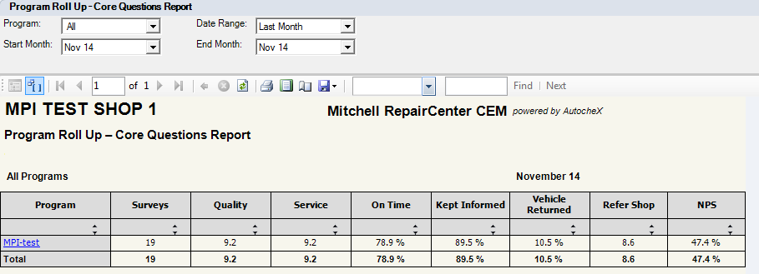

Summary Survey Completion Report
This report shows the number of surveys completed, alerts generated for the programs that utilize alerts, customer records received (sample) and time frame selected.

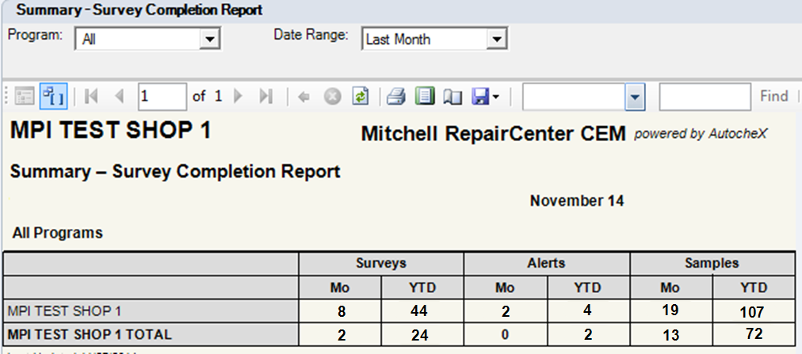

Trend Report
This report shows how the shop has performed on every question in the survey, month by month, over the past year. Select the applicable program to see the trending for that program.

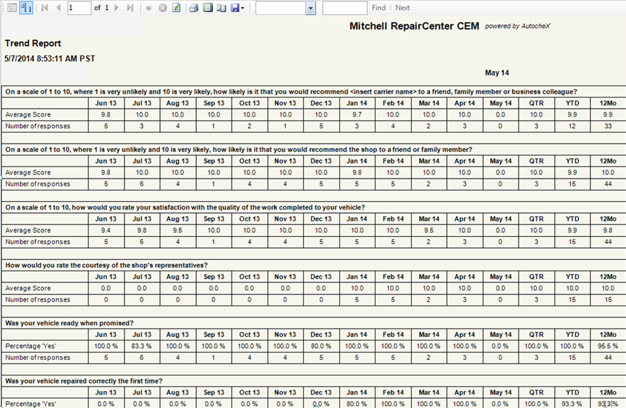

Mitchell AutocheX managing Favorites and Subscriptions

Creating a Favorite
If you tend to use the same reports frequently, you can save it for future use by opening the report and then clicking on the Favorites tab in RepairCenter. To do this, click on the “Save as Favorites” button located at the bottom right corner of the reports area. Manitoba Public Insurance would like all Repair Shops to add the following reports to their “Favorites”.

Customer Detail - Core Questions Report

Program Roll Up - Core Questions Report

Once the report is saved, just click on the Favorites tab and double click the report name to open it. The report will generate based on the parameters selected at the time the favorite was created.

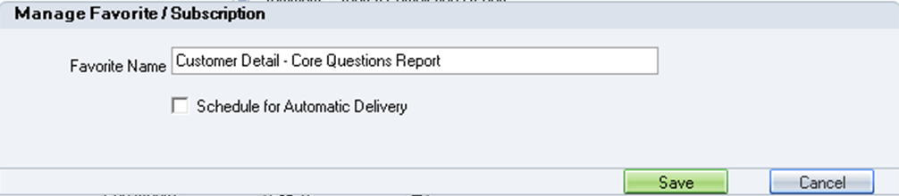

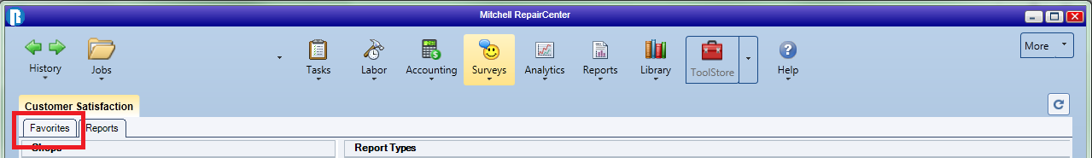

Creating a Subscription
When you save a report as a Favorite, there is also an option to schedule automatic delivery of the report daily, weekly or monthly to the email address (es) you designate. To create a subscription, check the “Schedule for Automatic Delivery” and complete the information in the “Send To” and “Schedule” area. Once completed, save your subscription.

MPI Recommended Report Subscriptions
Manitoba Public Insurance would like all Repair Shops to subscribe to automatic delivery of the following “Favorite Reports”. Manitoba Public Insurance asks that all Repair Shops schedule automatic delivery of the report daily, weekly or monthly to the email address (es) you designate.

Customer Detail - Core Questions Report

Program Roll Up - Core Questions Report

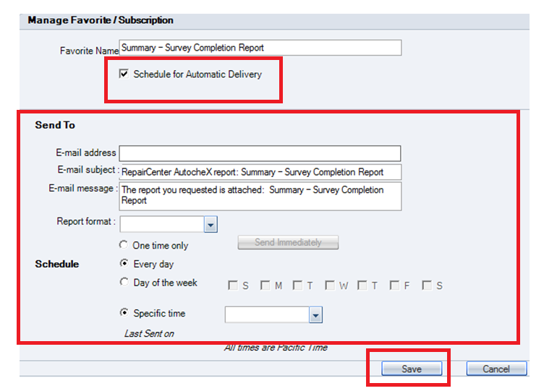

This concludes the overview of RepairCenter CEM.

If you have questions about using RepairCenter CEM call Mitchell Customer Service at 1-800-922-5129 or send an email to acxcustsvc@mitchell.com.

If you need technical support call Mitchell Tech Support at 1-800-448-4401, select Option 2 for Technical Support or you can create a support ticket via MiPortal Customer Support at https://www.mitchell.com/support

